

YILDIZ TECHNICAL UNIVERSITY
FACULTY OF CHEMISTRY-METALLURGICAL
DEPARTMENT OF MATHEMATICAL ENGINEERING

MULTIDISCIPLINARY DESIGN PROJECT

AN APPLICATION OF MACHINE LEARNING
IN MEDICAL DECISION MAKING

SUPERVISOR: Prof. Dr. Hale Gonce KÖÇKEN

21058007, Muhammed Kerem DEMİRBENT
21058023, Mustafa Berat YAVAŞ

İstanbul, 2025

© All rights of this report are reserved by Yıldız Technical University, department of Mathematical Engineering.

CONTENTS
CONTENTS ii
ABBREVIATION LIST iv
FIGURE LIST v
PREFACE vi
ABSTRACT vi
1. INTRODUCTION 1
1.1 Activities During the Reporting Period 1
1.2 Global and Local Burden of Cardiovascular Diseases 1
1.3 Problem Statement and Research Questions 2
2. DATASET 3
2.1 Dataset Source and General Characteristics 3
2.2 Variables and Their Clinical Significance 3
2.3 Inter-Feature Relationships and Correlation Analysis 4
2.4 Data Manipulation and Pre-processing 5
2.4.1 Missing Value Handling 5
2.4.2 Categorical Encoding 5
2.4.3 Redundancy Removal and Multicollinearity Diagnostics 6
2.4.4 Feature Scaling 6
2.4.5 Train/Test Partitioning and Leakage Prevention 6
2.4.6 Handling Class Imbalance — SMOTE Application 7
2.4.7 Outlier Detection and Treatment 7
2.4.8 Final Dataset Readiness and Reproducibility 7
3. DECİSİON OF MODELS AND COMPARE 8
3.1 Model Evaluation and Optimization 8
3.2 Algorithms Used 9
3.2.1 Random Forest 9
3.2.2 Decision Tree 9
3.2.3 K-Nearest Neighbors (KNN) 10
3.2.4 Support Vector Classifier (SVC) 12
3.2.5 Gradient Boosting 12
3.2.6 XGBoost 13
3.2.7 Logistic Regression 13
3.3 Comparative Model Performance 13
3.4 Confusion Matrices and Visualization 15
REFERENCES 17
RESUME 19

ABBREVIATION LIST
CVD / CVDs Cardiovascular Disease(s)
WHO World Health Organization
VIF Variance Inflation Factor
SMOTE Synthetic Minority Over-sampling Technique
SVC Support Vector Classifier
IQR Interquartile Range
OOB Out-Of-Bag
SHAP SHapley Additive exPlanations
ROC Receiver Operating Characteristic
TP / FP / TN / FN True Positive / False Positive / True Negative / False Negative
KNN k-Nearest Neighbors
XGBoost eXtreme Gradient Boosting

FIGURE LIST
Figure 2.1 Correlation heatmap of clinical and demographic variables.
Figure 3.1 Variance Inflation Factor Analysis Table
Figure 3.2 Model Performance Comparison Table
Figure 3.3 Confusion Matrix for Logistic Regression Model
Figure 3.4 Confusion Matrix for Gradient Boosting Model

PREFACE
This report has been prepared to present the progress and findings of the study developed within the scope of the Multidisciplinary Design Project. Titled "An Application of Machine Learning in Medical Decision Making", this work investigates the potential of machine learning models to support early diagnosis and prognosis. The project leverages the core competencies of the Mathematical Engineering discipline—specifically statistical modeling, optimization, and data analysis—to evaluate the 'Heart Disease Data' dataset acquired from Kaggle [1] from a multidisciplinary perspective. The ultimate objective is to develop a predictive model capable of estimating the presence of heart disease using clinical parameters. This work thus constitutes an applied synthesis of the knowledge acquired during undergraduate studies and explores the potential contribution of mathematical approaches to clinical analysis. We extend our sincere gratitude to our supervisor, Prof. Dr. Hale Gonce Köçken, for her invaluable guidance, constructive feedback, and continuous support throughout the execution of this project.

ABSTRACT
Cardiovascular disease continues to impose a significant global health burden, driving the demand for advanced analytical solutions capable of supporting early and objective diagnosis. This study investigates the application of machine learning techniques within the domain of clinical decision support, leveraging the mathematical engineering foundations of statistical modeling, optimization, and data analysis. Positioned at the intersection of mathematics, engineering, and medicine, the work seeks to translate routinely collected clinical parameters into actionable risk assessments, thereby enhancing the decision-making capacity of healthcare professionals. By focusing on the development of a robust predictive framework, the study emphasizes model interpretability, robustness, and relevance to real-world clinical workflows. The findings contribute to the broader agenda of bridging computational methodologies and medical practice, with implications for scalable diagnostic systems and proactive patient care.
Keywords: Machine learning, cardiovascular disease risk, clinical decision support, predictive modeling, model interpretability

1. INTRODUCTION
Cardiovascular disease remains a leading global health challenge, demanding innovative analytical solutions for early diagnosis and risk prediction. This study, conducted as part of the Multidisciplinary Design Project within the Mathematical Engineering Undergraduate Program at Yıldız Technical University, explores the potential of machine learning models to support cardiovascular disease (CVD) risk assessment and early diagnostic workflows. Situated at the convergence of mathematical modeling, statistical analysis and optimization, the work aims to offer a rigorous mathematical approach to a pressing public health concern.

1.1 Activities During the Reporting Period
During this reporting period, a robust data-engineering and model-preparation pipeline was meticulously implemented on the selected clinical dataset. Missing values were managed using the “SimpleImputer” method — numerical variables were imputed with their mean, and categorical variables with their most frequent value, thereby preserving dataset integrity. Categorical features were encoded using “LabelEncoder” and expanded via “OneHotEncoder,” with columns containing redundant dummy variables removed to streamline the feature set. Multicollinearity was assessed through variance inflation factor (VIF) analysis; features exhibiting VIF values greater than 2 were excluded, and a correlation heat map was generated to visualise inter-feature relationships. To mitigate class imbalance, the Synthetic Minority Over-sampling Technique (SMOTE) was applied, and all variables were standardised using “StandardScaler” to neutralise scale-driven bias in model training. A comprehensive suite of supervised classifiers — including k-Nearest Neighbours (KNN), Support Vector Classifier (SVC), XGBoost, Gradient Boosting, Logistic Regression, Decision Tree, and Random Forest — was trained and compared using confusion matrices alongside core performance metrics: accuracy, precision, recall (sensitivity), specificity, and F1-score. Preliminary findings indicate that under current conditions, KNN and Logistic Regression achieved the highest accuracy; however, selecting the definitive optimal model remains a meticulous task due to inherent trade-offs and the necessity for further data-centric refinements. The summary of these activities is presented in the following sections.

1.2 Global and Local Burden of Cardiovascular Diseases
Cardiovascular diseases (CVDs) — a group of disorders affecting the heart and blood vessels — represent one of the leading causes of morbidity and mortality worldwide [2]. According to the World Health Organization, an estimated 19.8 million people died from CVDs in 2022, with the majority of these deaths attributable to ischemic heart disease and stroke [2]. A substantial proportion of CVD mortality occurs in low- and middle-income countries, underscoring persistent global health inequities [2]. This substantial burden highlights the urgent need for reliable, scalable, and clinically integrable tools for early detection and targeted intervention [2].

1.3 Problem Statement and Research Questions
The central problem addressed in this study is whether routinely collected clinical parameters and demographic data can be used to reliably predict the presence of heart disease. The specific objectives are:
- To establish a systematic data-engineering pipeline (missing-value handling, categorical encoding, scaling, multicollinearity assessment).
- To train and compare multiple supervised classifiers (KNN, Logistic Regression, SVC, Decision Tree, Random Forest, Gradient Boosting, XGBoost, etc.) with respect to predictive performance and interpretability.
- To present a recommended model that balances performance with interpretability and clinical applicability, taking into account class imbalance, feature relationships, and model explainability (e.g., SHAP, coefficient analysis).

Research questions:
- RQ1: Can heart disease presence be predicted with acceptable accuracy and sensitivity using routine clinical features?
- RQ2: How do preprocessing steps (imputation, encoding, VIF-based multicollinearity removal) and resampling strategies (e.g., SMOTE) influence model performance?
- RQ3: Which classifiers provide the best trade-off between predictive performance and clinical interpretability?
- RQ4: How can model explainability methods be employed to increase clinician trust, and which features emerge as the strongest predictors?
These questions are designed to prioritize not only numerical performance but also reliability and interpretability necessary for clinical deployment.

2. DATASET

2.1 Dataset Source and General Characteristics
This study employs the publicly available Heart Disease dataset, originally compiled in the UCI Machine Learning Repository and accessed via the Kaggle distribution published by redwankarimsony. [1][3] The dataset aggregates records from four constituent databases (Cleveland, Hungary, Switzerland, and Long Beach VA) and is widely used in machine-learning research for cardiovascular risk assessment; for contextual information on the global burden of cardiovascular disease, see the World Health Organization (2024). [2] The version used in this work comprises 920 patient records and the conventionally used subset of 14 clinical and demographic features; although the full UCI collection contains up to 76 attributes, previous studies and standard experimental protocols typically employ the 14-attribute subset. [1][3] The target variable in the source compilations is recorded on an ordinal scale from 0 to 4 (commonly labelled “target” or “goal”) and encodes both the presence and reported severity of heart disease. In this study, the original multiclass encoding is preserved and each class (0, 1, 2, 3, 4) is treated as a distinct category for model development and evaluation; consequently, modelling, resampling (when applied), and performance assessment are conducted within a multiclass framework using per-class and aggregated metrics (for example, per-class recall, macro/weighted F1, confusion matrices, and one-vs-rest ROC analyses where appropriate). The data are publicly accessible for research purposes, and the analyses reported in this thesis preserve patient anonymity; the dataset’s provenance and terms of use are documented in the References. [1][3]

2.2 Variables and Their Clinical Significance
The fourteen features employed in this study comprise a mixture of demographic, hemodynamic, metabolic, electrocardiographic and imaging-derived variables routinely recorded during cardiovascular assessment. Demographic and systemic risk indicators—age, sex, resting blood pressure and serum cholesterol—reflect established non-modifiable and modifiable determinants of coronary risk. [5] These variables are represented in the Heart Disease dataset used in this work. [3][1] Metabolic status is represented by the fasting blood-sugar indicator (fbs), which serves as a proxy for impaired glucose metabolism and diabetes-related cardiovascular risk. [6] Clinical presentation and exercise-testing variables—chest pain type (cp), exercise-induced angina (exang), maximum heart rate achieved (thalach), exercise-induced ST-segment depression (oldpeak) and ST-segment slope (slope)—capture symptomatic and provoked ischemic responses that are central to the diagnostic evaluation of suspected coronary disease.

[4] Baseline resting electrocardiographic findings (restecg) and imaging-derived indices—number of major vessels (ca) and thallium perfusion result (thal)—provide complementary structural and perfusion information that correlate with anatomical disease burden and prognosis. [7] The supervised label (target) encodes the reported presence and ordinal severity of heart disease and was originally recorded on an ordinal scale from 0 to 4 in the source compilations; in this study the original multiclass encoding is preserved and each class (0, 1, 2, 3, 4) is treated as a distinct category for primary analyses, thereby enabling models and evaluation procedures to capture gradations of disease severity rather than a simple binary distinction. [3][1] Where numeric codes denote categorical states in the source files (for example cp, restecg, slope and thal), the documented mappings from the source distributions were preserved and applied consistently during preprocessing to ensure clinically interpretable feature engineering and model explanations; standard preprocessing utilities (imputation, encoding and scaling) from common libraries were used in accordance with their documented behaviour. [3][1][8][9]

2.3 Inter-Feature Relationships and Correlation Analysis
Figure 2.1 displays the pairwise Pearson correlation heatmap, providing a concise overview of linear associations among the preprocessed predictors. The target variable exhibits moderate positive associations with age and the asymptomatic indicator, and negative associations with maximum exercise heart rate (thalach) and the female indicator. Notably, these bivariate coefficients indicate the direction and relative strength of association, not causation.
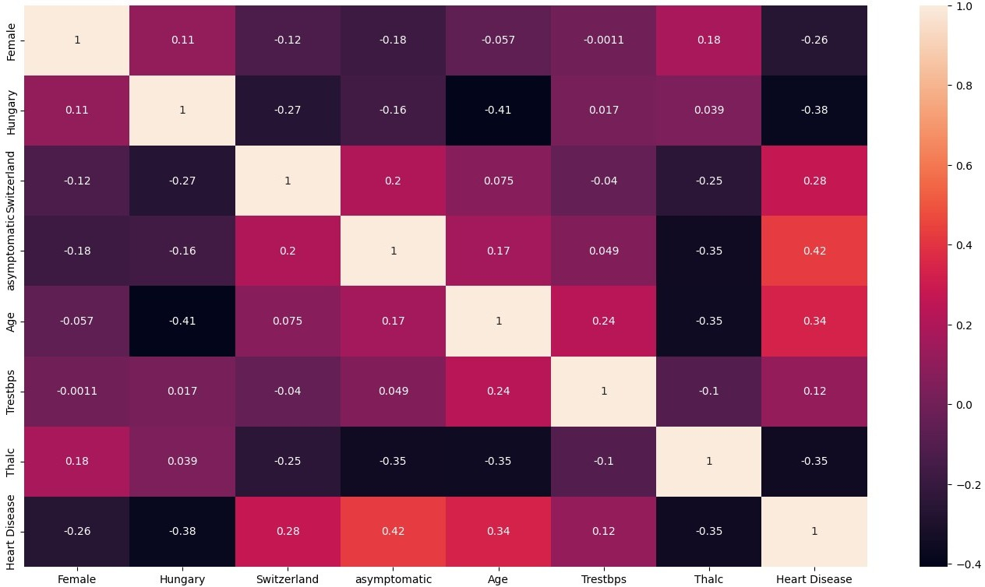
Figure 2.1 Correlation heatmap of clinical and demographic variables.
Two cautions are noted:
  - Pearson correlation assumes continuous variables and approximately linear relationships; when applied to numerically encoded categorical variables it can yield misleading magnitudes—use point-biserial correlation for binary–continuous pairs, Spearman rank correlation for ordinal variables, and Cramér’s V or chi-square-based measures for nominal–nominal associations (or evaluate one-hot dummies separately) as appropriate.
  - provenance (source/country) dummy variables may reflect sampling or measurement heterogeneity rather than intrinsic clinical effects. Consequently, pairwise inspection is supplemented by multivariate diagnostics (VIF and regression-based checks) and appropriate categorical association measures during preprocessing. All selection and transformation steps are performed using training-fold statistics within the cross-validation protocol to avoid information leakage.

2.4 Data Manipulation and Pre-processing
This section describes the sequential data manipulation and pre-processing operations applied to the Heart Disease dataset. All steps were implemented with care to prevent information leakage and to ensure reproducibility.

2.4.1 Missing Value Handling
Missing numerical values were imputed using scikit-learn’s SimpleImputer with the mean strategy; missing categorical values were imputed with the most_frequent strategy. Imputation parameters (means or modes) were always estimated from the training partition within each cross-validation fold and then applied to validation/test partitions to avoid data leakage. [8]

2.4.2 Categorical Encoding
Categorical variables were first mapped to integer labels (using LabelEncoder / OrdinalEncoder where ordinal interpretation was appropriate) and subsequently expanded into binary indicator columns via One-Hot Encoding (OneHotEncoder). Where necessary, one dummy column per categorical variable was dropped to avoid perfect multicollinearity (the dummy-variable trap). All encoders were fitted on training data only and persisted for application to held-out folds. Implementation details follow standard scikit-learn conventions. [9]

2.4.3 Redundancy Removal and Multicollinearity Diagnostics
Redundant columns produced by one-hot encoding were removed when they offered no additional information. Multivariate collinearity was assessed using the Variance Inflation Factor (VIF). For predictor $j$,
$${VIF}_{j} = \frac{1}{1-R_{j}^{2}},$$
where $R_{j}^{2}$is the coefficient of determination from regressing predictor $X_{j}$on the remaining predictors. Predictors with elevated VIF values were flagged for removal or combination; conventional thresholds were considered together with domain knowledge in final decisions. VIF calculations were performed on training partitions to prevent cross-fold contamination. [12]

2.4.4 Feature Scaling
Continuous features were standardised to zero mean and unit variance using scikit-learn’s StandardScaler. The z-score transform applied to feature $j$is
$${\tilde{x}}_{ij}=\frac{x_{ij}-μ_{j}}{σ_{j}},$$
where $μ_{j}$and $σ_{j}$are the training-set mean and standard deviation, respectively. Scaling parameters were computed on the training partition and then reused for validation/test partitions. Standardisation reduces scale-driven bias for distance-based and regularised models. [9]

2.4.5 Train/Test Partitioning and Leakage Prevention
Data were split into stratified training and test sets, with inner stratified folds used for hyperparameter tuning. All preprocessing steps that estimate parameters or transform distributions (imputation, encoder fitting, VIF screening, scaling, resampling) were conducted only on the training partition inside each cross-validation iteration and then applied to hold-out data to avoid information leakage.

2.4.6 Handling Class Imbalance — SMOTE Application
Imbalanced class distributions in the training set were addressed with SMOTE (Synthetic Minority Over-sampling Technique). SMOTE synthesises new minority samples by linear interpolation between a minority instance $x_{i}$and one of its $k$nearest minority neighbours $x_{nn}$:
$$x_{\text{new}}=x_{i}+λ (x_{nn}-x_{i}),λ∼U(0,1).$$
SMOTE was applied only to the training partition within each fold; the choice of $k$and desired resampling ratio were tuned via inner cross-validation. [10]

2.4.7 Outlier Detection and Treatment
Outliers were identified via robust statistical rules and visual diagnostics. The primary automatic rule employed was Tukey’s IQR criterion: observations below $Q_{1}-1.5⋅IQR$or above $Q_{3}+1.5⋅IQR$(where $IQR=Q_{3}-Q_{1}$) were flagged for review. Complementary checks used standardized z-scores and domain knowledge to detect physiologically implausible values. Flagged cases were inspected and then winsorised, transformed, or removed depending on the likely cause (measurement/transcription error vs plausible extreme value). All outlier handling was performed on training folds and documented. [11]

2.4.8 Final Dataset Readiness and Reproducibility
Following imputation, encoding, redundancy removal, VIF-based selection, scaling, SMOTE (train only) and outlier treatment, the dataset was considered ready for model training. The preprocessing pipeline was implemented as a sequence of transformers and persisted mappings (encoder classes, imputer statistics, scaler parameters, and SMOTE configuration) were saved to ensure reproducibility of results. Implementation adhered to scikit-learn best practices. [8], [9]

3. DECİSİON OF MODELS AND COMPARE

3.1 Model Evaluation and Optimization
Multiple metrics exist to evaluate the performance of classification algorithms. The selection of performance metrics depends on the specific problem type we need to address [13]. Prior to commencing the model evaluation process, the Ordinary Least Squares was examined as a baseline prediction model but was ultimately rejected due to methodological inadequacy. This method assumes that the dependent variable is continuous, whereas our target variable consists of ordinal categories ranging from 0 to 4. This incompatibility led the model to predict clinically uninterpretable fractional values, such as 1.73, effectively nullifying its predictive relevance. Although the internal consistency of the predictors was successfully verified through the analysis of Variance Inflation Factor, classification metrics like the F1 Score became necessary to accurately measure predictive performance. Consequently, subsequent analyses focused exclusively on algorithms suitable for ordinal classification tasks.

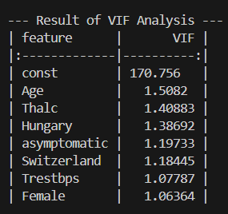

Figure 3.1 Variance Inflation Factor Analysis Table

3.2 Algorithms Used

3.2.1 Random Forest
Let $D=\{(x_{i},y_{i})\}_{i=1}^{n}$denote the training sample with predictors $x_{i}∈R^{p}$and labels $y_{i}$. A random forest constructs an ensemble of $M$randomized decision trees $\{h(x;Θ_{m})\}_{m=1}^{M}$, where each $Θ_{m}$is an independent random vector encoding the stochastic elements of tree construction (principally a bootstrap sample of $D$and random feature selection at each split). For classification the ensemble prediction is given by the majority-vote rule
$${\hat{H}}_{M}(x) = arg⁡\underset{y}{max⁡} \sum_{m=1}^{M}{}1\{h(x;Θ_{m})=y\},$$
with the corresponding class probability estimate
$${\hat{P}}_{M}(y∣x) = \frac{1}{M}\sum_{m=1}^{M}{}1\{h(x;Θ_{m})=y\}.$$
Breiman’s theoretical and empirical analysis demonstrates that, as $M→∞$, the forest’s generalisation error converges to a limit governed principally by the average strength of the constituent trees and their pairwise correlations, motivating the use of random feature selection to reduce correlation while preserving individual tree strength [17]. Out-of-bag (OOB) samples—observations excluded from a given tree’s bootstrap sample—provide an internal, unbiased estimate of prediction error and permit computation of variable importance without recourse to separate cross-validation. Key hyperparameters include the number of trees $M$, the number of candidate features considered at each split ($m_{\text{try}}$), and stopping/leaf-size criteria; these parameters mediate the bias–variance trade-off and computational cost of the ensemble.

3.2.2 Decision Tree
Decision trees were selected for this study because of their interpretability and their straightforward graphical representation, which facilitates communication of the model’s decision logic to clinical practitioners. Formally, a classification tree is constructed by recursively partitioning the feature space $R^{p}$into disjoint regions $\{R_{m}\}_{m=1}^{M}$and assigning to each region a class label (typically the majority class among training observations that fall in that region).

A binary split on feature $j$at threshold $s$produces child regions
$$R_{\text{left}}=\{x:x_{j}≤s\},R_{\text{right}}=\{x:x_{j}>s\},$$
and the split $(j,s)$is selected to maximise the impurity reduction
$$ΔI = I(τ)-\frac{n_{\text{left}}}{n_{τ}}I(τ_{\text{left}})-\frac{n_{\text{right}}}{n_{τ}}I(τ_{\text{right}}),$$
where $I(⋅)$denotes a node impurity function (for example the Gini index $G(τ)=1-\sum_{k}{}p_{k}^{2}$or the Shannon entropy $H(τ)=-\sum_{k}{}p_{k}log⁡p_{k}$), $n_{τ}$is the number of samples at node $τ$, and $p_{k}$are the class proportions at that node. The recursion terminates according to stopping criteria (minimum node size, maximum depth, or purity threshold), and trees are commonly post-pruned using cost–complexity regularisation which seeks the subtree $T$minimising
$$R_{α}(T) = R(T)+α ∣T∣,$$
where $R(T)$is the empirical risk (for example misclassification cost) of tree $T$, $∣T∣$its number of terminal nodes, and $α≥0$a complexity penalty that mediates the bias–variance trade-off. Decision trees naturally handle mixed data types, capture nonlinear feature interactions, and yield decision rules that can be directly inspected and translated into clinical heuristics; their principal limitations include sensitivity to training-set perturbations and a tendency to overfit unless controlled by pruning or ensembling. [18]

3.2.3 K-Nearest Neighbors (KNN)
K-Nearest Neighbors (KNN) is a non-parametric, instance-based supervised learning algorithm commonly employed for classification and, less frequently, for regression. Given a query point $x$, KNN identifies the set of $k$training instances whose feature vectors are nearest to $x$according to a chosen distance metric, and produces a prediction by aggregating those neighbours’ responses (majority vote for classification; arithmetic mean for regression). The algorithm’s behaviour is controlled principally by the choice of $k$, the distance metric, any neighbour-weighting scheme (e.g. distance-weighted voting), and preprocessing such as feature scaling.

- Euclidean distance: The Euclidean distance is the ordinary straight-line distance in $p$-dimensional feature space:
$$d_{\text{Euclid}}(x,x_{i}) = {(\sum_{j=1}^{p}{}(x_{j}-x_{i,j})^{2})}^{\text{ ⁣}1/2}.$$
- Manhattan distance: The Manhattan (or $L_{1}$) distance measures the sum of absolute coordinate differences:
$$d_{\text{Manhattan}}(x,x_{i}) = \sum_{j=1}^{p}{}∣x_{j}-x_{i,j}∣.$$
- Minkowski distance: The Minkowski distance is a general $L_{p}$family that subsumes both Euclidean and Manhattan distances as special cases:
$$d_{\text{Minkowski}}(x,x_{i}) = {(\sum_{j=1}^{p}{}∣x_{j}-x_{i,j}∣^{p})}^{\text{ ⁣}1/p},$$
where $p≥1$. In particular, $p=1$yields the Manhattan distance and $p=2$yields the Euclidean distance. In this study we employed the Minkowski distance (with the exponent $p$treated as a hyperparameter and selected via cross-validation), as it provides a flexible family of metrics from which the most appropriate member may be chosen for the dataset at hand.
Practical considerations — K selection, scaling and weighting: the choice of $k$trades bias against variance (small $k$can lead to overfitting; large $k$smooths predictions but may underfit). Because KNN is distance-based, feature scaling (e.g. standardisation or min–max scaling) is essential when predictors are measured on different scales. Optionally, distance-weighted voting (weighting each neighbour’s vote by $1/d$or a similar kernel) may be used to give nearer neighbours greater influence and to mitigate ties. [19]

3.2.4 Support Vector Classifier (SVC)
The Support Vector Classifier operates by identifying the optimal hyperplane that distinctly separates data points into different classes while maximizing the margin between them. By utilising the “kernel trick,” this method can implicitly map data into a higher-dimensional feature space, making it highly effective for complex, non-linear decision boundaries. [3]
Mathematically, for a binary classification problem with training data $\{(x_{i},y_{i})\}, y_{i}∈\{-1,+1\}$, the soft-margin SVC solves:
$$\underset{w,b,ζ}{min⁡} \frac{1}{2}∥w∥^{2}+C\sum_{i=1}^{n}{}ζ_{i},\text{s.t. }y_{i}(w^{⊤}ϕ(x_{i})+b)≥1-ζ_{i}, ζ_{i}≥0,$$
where $ϕ(⋅)$is a (possibly implicit) feature mapping induced by the kernel, $C>0$is the regularisation parameter, and $ζ_{i}$are slack variables. [turn0search0][turn0search14]
Because only the support vectors (training points for which $0<ζ_{i}$or equality holds) determine the decision boundary, the model tends to generalise well. However, it can be computationally intensive for large datasets and is sensitive to the choice of kernel and hyperparameters.

3.2.5 Gradient Boosting
Gradient Boosting is an ensemble method that sequentially combines many weak learners (typically decision trees) to construct a more accurate predictor. Each new model is trained to fit the residual errors of its predecessor, thereby minimizing a specified loss function via gradient descent. [turn0search13][turn0search16]
In each iteration $m=1…M$, a weak learner $h_{m}(x)$is fitted to the negative gradient of the loss $L(y,F_{m-1}(x))$with respect to the current prediction $F_{m-1}(x)$, and the updated model is:
$$F_{m}(x)=F_{m-1}(x)+η h_{m}(x),$$
where $η∈(0,1]$is the learning rate. This technique excels at capturing complex, non-linear relationships within the data, though it demands careful tuning of parameters (such as number of estimators, tree depth, learning rate) to avoid overfitting. [14]

3.2.6 XGBoost
XGBoost represents a highly optimized implementation of the Gradient Boosting framework, designed for both speed and performance. It incorporates advanced features such as parallel computation of tree building, regularisation terms within the objective function, and improved approximations of the loss function to prevent overfitting and accelerate training. It has consistently ranked among the top-performing algorithms in machine-learning competitions and real-world industrial applications. [15]

3.2.7 Logistic Regression
Logistic Regression is a foundational linear model that predicts the probability of an outcome by modelling the log-odds of the target class as a linear combination of input features. For binary classification, the model takes the form:
$$P(y=1∣x)=\frac{1}{1+exp⁡(-w^{⊤}x-b)},$$
where $w$are the feature coefficients and $b$the bias. Because each coefficient directly corresponds to the log-odds change per unit feature change, the model offers high interpretability. In multiclass scenarios it can be extended via One-vs-Rest or Multinomial formulations. [16]

3.3 Comparative Model Performance
The investigation began with a comprehensive literature review of machine-learning methodologies, followed by empirical testing of each candidate model. The results indicated that the Naïve Bayes algorithm produced the lowest performance, primarily Figure 3.2 Model performance comparison table
because the assumption of feature independence was violated in this dataset. The Decision Tree algorithm, while interpretable, exhibited a strong tendency to overfit, leading to sub-optimal generalisation.

Several models—including Random Forest, KNN, SVC, Logistic Regression and XGBoost—achieved closely clustered F1-Scores, suggesting similar overall accuracy. However, a deeper per-class analysis revealed that each method possessed distinct strengths and weaknesses across clinical severity classes. For instance, Logistic Regression attained the highest Recall for the particularly challenging Stage 4 class.
Ultimately, Gradient Boosting emerged as the most effective method, achieving the highest overall F1-Score. Although the application of SMOTE improved overall multiclass performance, the modest success rates observed are hypothesised to stem from the presence of uncleaned outliers in the dataset. Consequently, outlier detection and removal have been identified as the next critical step to further enhance model accuracy.

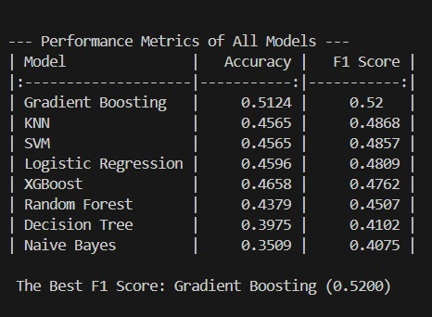
Figure 3.2 Model Performance Comparison Table

3.4 Confusion Matrices and Visualization
A confusion matrix is a specialized table structure that allows users to visualise the performance of supervised learning algorithms by comparing predicted labels with true labels. [13] It provides a breakdown of correct and incorrect classifications across all classes, which aids in interpreting model behaviour and error patterns. In the present study, confusion matrices are used alongside derived metrics (such as precision, recall, F1-score) to present and compare performance for both the Gradient Boosting and Logistic Regression models.

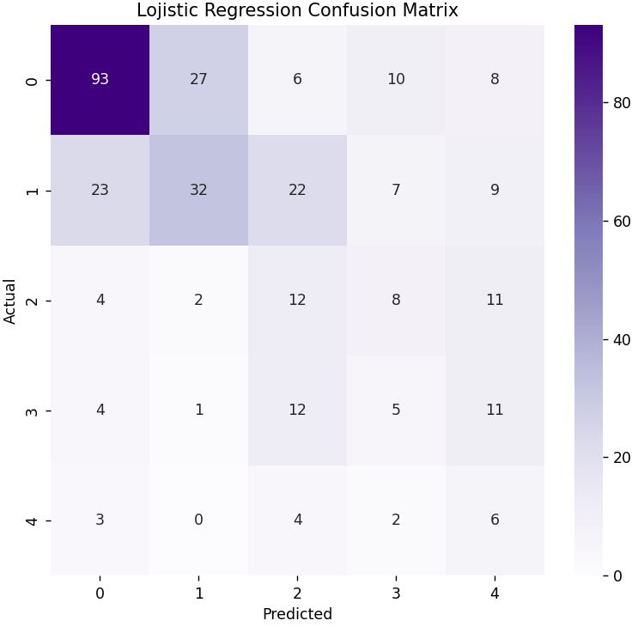
Figure 3.3 Confusion Matrix for Logistic Regression Model

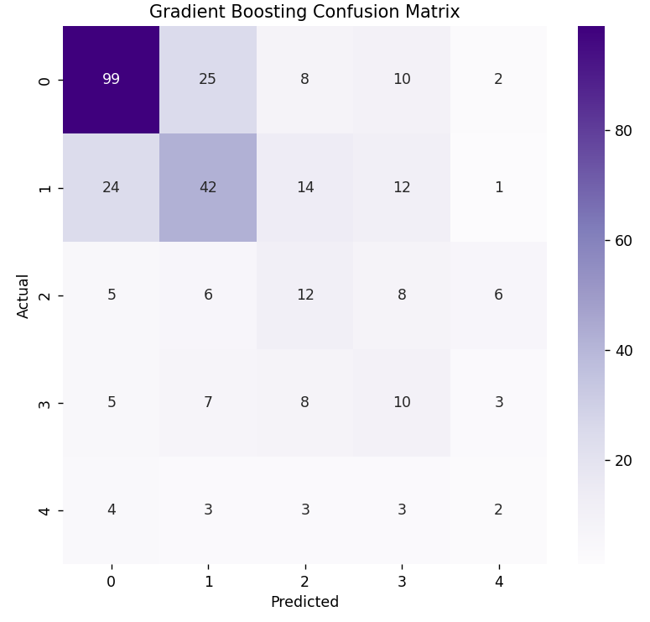

Figure 3.4 Confusion Matrix for Gradient Boosting Model
In the subsequent phases of this study, the primary objective is to eliminate all residual issues identified within the dataset, which have been recognized as the main source of performance degradation in the current models. To enhance the model’s predictive capability, the potential of Deep Learning methods will be thoroughly explored, particularly in cases where traditional machine learning algorithms prove insufficient. Furthermore, the approximately 85% accuracy achieved when the dependent variable was transformed into a binary format has been retained as a benchmark for the final solution. To support this analytical process and facilitate interpretation, high-resolution and explanatory visualizations will be incorporated using Matplotlib. Although the dataset’s structural relationships have already been examined through the correlation matrix, this comprehensive data-cleaning process and the integration of Deep Learning techniques are expected to enable the development of a reliable and high-performing predictive model—the ultimate goal of the project.

REFERENCES

[1] redwankarimsony. (n.d.). UCI Heart Disease Data. Kaggle. Retrieved November 2, 2025, from https://www.kaggle.com/datasets/redwankarimsony/heart-disease-data
[2] World Health Organization. (2024). Cardiovascular diseases (CVDs) — fact sheet. Retrieved November 2, 2025, from https://www.who.int/news-room/fact-sheets/detail/cardiovascular-diseases-(cvds)
[3] UCI Machine Learning Repository. (n.d.). Heart Disease Data Set. Retrieved November 2, 2025, from https://archive.ics.uci.edu/ml/datasets/Heart+Disease
[4] Mayo Clinic. (2024). Angina — Symptoms and causes. Retrieved November 2, 2025, from https://www.mayoclinic.org/diseases-conditions/angina/symptoms-causes/syc-20369373
[5] American Heart Association. (2024). Cholesterol. Retrieved November 2, 2025, from https://www.heart.org/en/health-topics/cholesterol
[6] American Diabetes Association. (2024). Diabetes diagnosis & tests. Retrieved November 2, 2025, from https://diabetes.org/about-diabetes/diagnosis
[7] RadiologyInfo.org. (2024). Cardiac (Heart) Nuclear Medicine. Retrieved November 2, 2025, from https://www.radiologyinfo.org/en/info/cardinuclear
[8] Scikit-learn developers. (n.d.). SimpleImputer. scikit-learn documentation. Retrieved November 2, 2025, from https://scikit-learn.org/stable/modules/generated/sklearn.impute.SimpleImputer.html
[9] Scikit-learn developers. (n.d.). OneHotEncoder, LabelEncoder, and StandardScaler. scikit-learn documentation. Retrieved November 2, 2025, from https://scikit-learn.org/stable/modules/preprocessing.html
[10] Chawla, N. V., Bowyer, K. W., Hall, L. O., & Kegelmeyer, W. P. (2002). SMOTE: Synthetic Minority Over-sampling Technique. Journal of Artificial Intelligence Research, 16, 321–357. https://doi.org/10.1613/jair.953
[11] Tukey, J. W. (1977). Exploratory data analysis. Reading, MA: Addison-Wesley.
[12] Marcoulides, K. M., & Schumacker, R. A. N. (2018). Evaluation of variance inflation factors in regression. PLoS ONE, 13(6), e0197411. https://doi.org/10.1371/journal.pone.0197411
[13] Chinthagumpala, M. V. (2025). Enhancing heart disease prediction through machine learning: A comprehensive approach (Doctoral dissertation, California State University San Marcos).
[14] Friedman, J. H. (2001). Greedy function approximation: A gradient boosting machine. Annals of Statistics, 29(5), 1189–1232.
[15] Chen, T., & Guestrin, C. (2016, August). XGBoost: A scalable tree boosting system. In Proceedings of the 22nd ACM SIGKDD International Conference on Knowledge Discovery and Data Mining (pp. 785–794). ACM.
[16] Hosmer, D. W., Lemeshow, S., & Sturdivant, R. X. (2013). Applied logistic regression (3rd ed.). Wiley.
[17] Breiman, L. (2001). Random forests. Machine Learning, 45(1), 5–32. https://doi.org/10.1023/A:1010933404324
[18] Breiman, L., Friedman, J. H., Olshen, R. A., & Stone, C. J. (1984). Classification and regression trees. Wadsworth & Brooks/Cole.
[19] Zhang, Z. (2016). Introduction to machine learning: k-nearest neighbors. Annals of Translational Medicine, 4(11), 218. https://doi.org/10.21037/atm.2016.03.37

RESUME
Name Surname Mustafa Berat Yavaş
Birth Date 24.05.2002
Birth Place Amasya
High School Alptekin Anatolian High School

Name Surname Muhammed Kerem Demirbent
Birth Date 01.06.2003
Birth Place İstanbul
High School Fatih Gelenbevi Anatolian High School

